Your chance to comment on the
Revised Publication Selby Local Plan
The Selby Local Plan contains allocated development sites and the planning policies to assess planning applications.
It has been revised in response to updated information and representations from the consultation in 2022
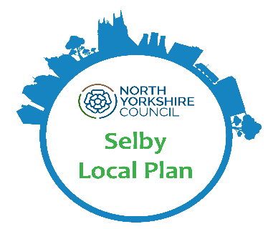
For further details and to view and comment on the Revised Publication Selby Local Plan
see our online consultation portal
https://selby-consult.objective.co.uk/kse
Representations must be received
no later than 4.30pm on 19 April 2024
If you need more information,
please contact the Selby area Planning Policy Team on
0300 131 2 131 or via the website at: https://www.northyorks.gov.uk/your-council/get-touch/contact-us

